Experiment-6 | Create a 3-dimensional array and perform operations like element access and slicing.
Date: 7-08-2025

Aim: To create a three-dimensional array in R and perform various operations such as accessing individual elements, extracting slices, and manipulating data within the array.
Software Requirement:
R studio and Visual Studio with R studio Environment
Theory:
In R, an array is a data structure that can store elements of the same type in multiple dimensions.
- A 3-dimensional array can be visualized as a collection of matrices stacked together.
- Arrays are created using the array() function in R:
1. Element Access:
- Using indexing: array_name[row, column, layer]
2. Slicing:
- Extracting a subset of data by leaving one or more indices empty or using ranges.
- Example: array_name[ , , 2] → selects the 2nd matrix (layer).

Algorithm Steps:
- Start
- Define the data to store in the array (numeric or character).
- Create the array using the array() function and specify dimensions.
- Display the complete array.
- Access a single element using specific row, column, and layer indices.
- Slice:
- Extract an entire row from a specific layer.
- Extract an entire column from a specific layer.
- Extract an entire layer (matrix).
- Print the results of each operation.
Program:
# Step 1: Create a 3D array
data <- 1:24 # numbers from 1 to 24
my_array <- array(data, dim = c(3, 4, 2)) # 3 rows, 4 columns, 2 layers

# Step 2: Display the array
print("The 3D Array:")
print(my_array)

# Step 3: Access a specific element (2nd row, 3rd column, 1st layer)
element <- my_array[2, 3, 1]
print(paste("Element at (2, 3, 1):", element))

# Step 4: Slice - entire row from layer 2 (row 1)
row_slice <- my_array[1, , 2]
print("Row 1 from Layer 2:")
print(row_slice)

# Step 5: Slice - entire column from layer 1 (column 2)
column_slice <- my_array[, 2, 1]
print("Column 2 from Layer 1:")
print(column_slice)

# Step 6: Slice - entire layer 1
layer_slice <- my_array[ , , 1]
print("Layer 1:")
print(layer_slice)

Result:
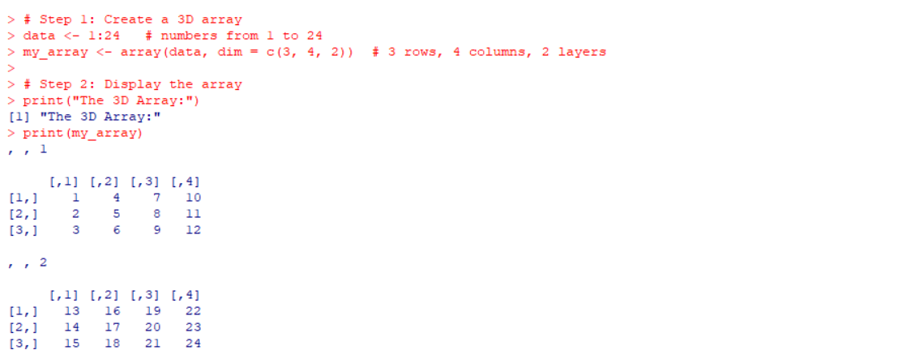
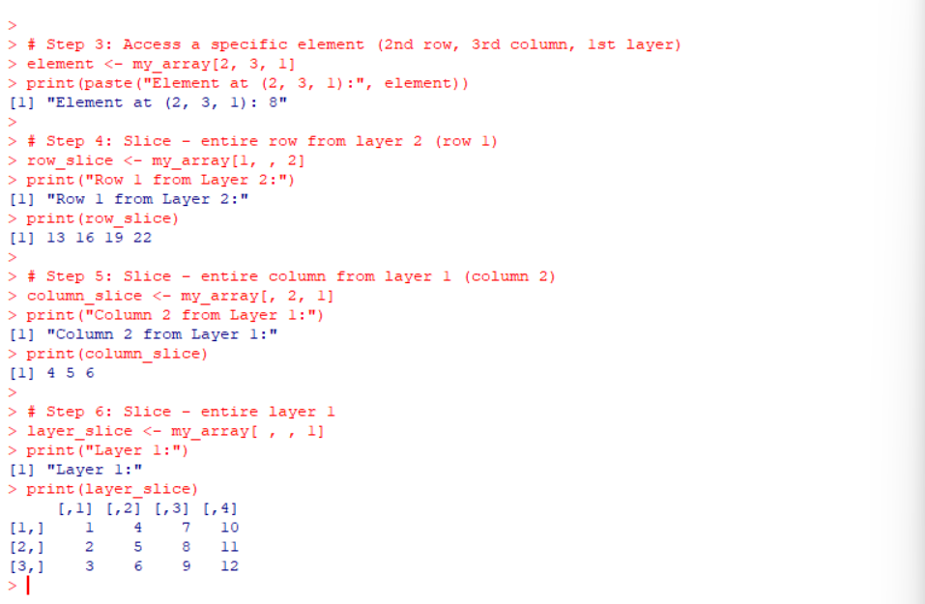

Summary of the Experiment:
In this lab session we learned how to create and manipulate a 3-dimensional array in R. We used the array() function to define a dataset of size 3×4×23 \times 4 \times 23×4×2 and performed different operations:
- Accessing a specific element using [row, column, layer] indexing.
- Extracting entire rows, columns, and layers using slicing techniques.
This practical exercise demonstrated the flexibility of R in handling multidimensional data structures, which is useful in areas like statistical computing, machine learning, and scientific simulations.

